TO: Don Onwiler, Executive Director NCWM August 22, 2028

Jason Flint, Chair S&T Committee

David Aguayo, S&T Committee

James Willis, S&T Committee

Mark Lovisa, S&T Committee

Loren Minnich, NIST, Office of Weights and Measures

Juana Williams, NIST, Office of Weights and Measures

Diane Lee, Office of Weights and Measures

FROM: William Hardy, Power Measurements, LLC submitter of EVF 23.4

Keith Bradley, Electrify America submitter of EVF 23.7

Additional supporters:

Theodore Brillhart, Fluke

Perry Lawton, Tesco-The Eastern Specialty Company

The above submitters and other interested parties listed have met several times and arrived at the following recommendation regarding EVF 23.4 and EVF 23.7.

Several pieces of EVF-23.4 and EVF-23.7 have become moot, due to the passage of EVF-23.1 at the 2023 Annual Meeting. Namely, EVF-23.4 proposed changes to S.5.2; and EVF-23.7 proposed changes to S.5.3, and the removal of N.1 and N.2. These changes proposed by EVF-23.4 and EVF-23.7 have now been made, and the corresponding text from EVF-23.4 and EVF-23.7 can be removed.

The submitters jointly request that the section of their Form 15s which deal with section N.5 and Appendix D be replaced with the following:

**Amend Handbook 44 (2024 Edition), Section 3.4 Electric Vehicle Fueling Systems as follows:**

**Strike the entirety of section N.3 and replace it with the following:**

### N.3. Test of an EVSE System.

The testing methodology compares the total energy delivered in a transaction and the total cost charged as displayed/reported by the EVSE with that measured by the measurement standard.  Each test shall be performed for at least the minimum measured quantity (MMQ).

N.3.1. Testing of an AC EVSE

Accuracy tests shall be performed at the following current levels:

(i) A point between 4 A and 10 A; and

(ii) A point between 40 % and 60 % of the MDA; and

(iii) A point between 70 % and 100 % of the MDA.

N.3.2. Type Evaluation Testing of a DC EVSE

Tests shall be performed at the following voltage points one between 350 VDC and 450 VDC and if supported by the EVSE a second at between 700 VDC and 900 VDC:

Accuracy tests shall be performed at the following current levels:

1. A point between 10% and 20% of the MDA, but not less than 30 A;
2. A point between 40 % and 60% of the MDA; and
3. A point between 70 % and 100 % of the MDA.

N.3.3. Performance Verification in the Field of a DC EVSE

Accuracy tests shall be performed at any convenient voltage and the following current levels:

1. A point between 10% and 20% of the MDA, but not less than 30 A; and
2. A point between 25 % and 100 % of the MDA, with the recommendation to test at the maximum power level within that range that is possible using the test equipment available.

Note: The test points (i) and (ii) above must not be at the same current level. It is recommended that the current levels should be separated to the extent that the test equipment will allow.

For DC systems it is anticipated that an electric vehicle may be used as the test load. Under that circumstance, testing at the load presented by the vehicle shall be sufficient for field verification provided that it is greater than 40 % of the MDA and no less than 30 A.

All DC EVSE are exempt from this requirement until January 1, 2028.

(Amended 2023)

**Add these definitions to HB44 Appendix D**

Maximum current deliverable:  The maximum current that the EVSE can deliver as installed under optimum conditions.

Maximum deliverable amperage: The maximum current available from the EVSE at the time of the test as determined by the Control Pilot Pulse Width Modulation signal or via digital communication between the EVSE and EV or test equipment.

**Change S.3.2 (b) to read.**

(b) Maximum current deliverable

**Add S.3.3 (e) to read.**

(e) MCD = Maximum current deliverable

**Justification**

The purpose of this proposal is to provide a uniform testing framework that can be straightforwardly implemented and covers the vast majority of use cases expected in the near future. This is a very rapidly developing marketplace with new electric vehicle applications arriving every week. These new applications stretch the voltage, current and power ranges that need to be covered. The submitters believe that the test process specified in the new N.5 provides a flexible structure as the market continues to develop.

Basic Philosophy

Two basic types of testing are envisioned for all EVSE: (1) Type testing is performed on a representative sample or samples of the product in a facility equipped to test over the entire range of performance specified by the standard. This testing will cover the full range of voltage, current and power levels as well as such issues as performance over the entire temperature range and in the presence of influence factors and disturbances. (2) Field verification is performed after the installation of a product, which has been previously type approved, in the field or on a periodic inspection or complaint resolution basis. The field verification of high-power DC chargers is particularly challenging to achieve at scale. The present requirement to test at 85% of a charger’s maximum current has made it difficult to build practical field test equipment for chargers that, in present-day service, are frequently capable of up to 500 amps or 600 amps. The proposal would allow a test to be conducted at possibly 25% of the charger’s maximum current if that is the most the test equipment can handle.

AC Testing

For accuracy testing, we test EVSE at three points: (1) at a point near the lowest current that a light duty electric vehicle will draw (6A per IEC 61851-1), (2) a point in the middle of the range, (3) a point near the top of the range. In HB44 these three ranges are:

(i) A point between 4 A and 10 A; and

(ii) A point between 40 % and 60 % of the MDA; and

(iii) A point between 70 % and 100 % of the MDA.

Wide bands are allowed about each of the target points to make test equipment less complicated by not requiring adjustment of the loads in small increments. This approach is in good alignment with OIML G22[1] (see Appendix A) where the mandatory current test points are *I*min, *I*tr , 50 % *I*max and *I*max.

For AC systems testing at the three current load points is easy to perform so there is no reason to have a different process for type evaluation and field verification.

DC Testing

The desired testing regime for DC EVSE is essentially the same as for AC EVSE with small differences. In AC the nominal voltage only varies from 208 VAC to 240 VAC. For DC EVSE the voltage can vary from about 150 VDC to 950 VDC with most charging being done either near 400 VDC or for newer systems near 800 VDC. For that reason, type evaluation should always include a voltage near 400 VDC and should include further testing near 800 VDC if the EVSE is capable of operation at that level.

For type testing we have followed the same path of three test points:

1. A point between 10% and 20% of the MDA, but not less than 30 A;
2. A point between 40 % and 60% of the MDA; and
3. A point between 70 % and 100 % of the MDA.

Points (ii) and (iii) are the same as for AC. However, the low current point has an added provision that the test current at this point shall not be less than 30 A. This restriction was added at the strong urging of the EVSE manufacturers and operators based on the difficulty of building meters that simultaneously operate over a large dynamic range and to low current levels.



We believe the 30 A limit represents a reasonable compromise and is in alignment with how other regulatory bodies have treated the issue.

Table 1 of OIML G22 provides the following guidance on over what range compared to *I*max the EVSE must meet its class accuracy. Note that *I*tr is the lowest current at which an EVSE meets its class accuracy.

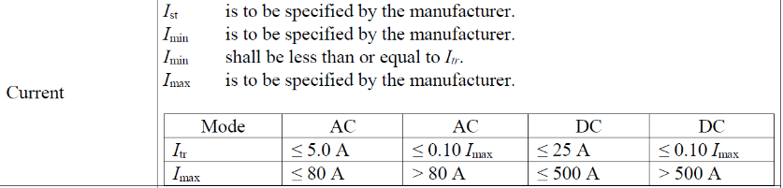Table 1 (excerpt)

For EVSE with *I*max ≤ 500A then *I*tr can have a maximum value of 25 A. For EVSE with *I*max > 500A then *I*tr can have a maximum value of 0.1*I*max.(so >50 A). Our single limit of >30A is quite comparable .

These low current restrictions are driven by the realities of how DC current sensors work. Whether a simple resistive shunt, hall effect sensor or flux linked device all have significantly more error at low currents because of DC offsets and noise.

The 30A limit provides appropriate coverage in the marketplace, and the behavior of actual vehicles confirms that currents below 30 A are not significant for transactional accuracy. Below we show charging curves for several vehicles. These curves show the actual current that each of these vehicles draws when connected to a charger with enough capacity; these currents are the limitations of the vehicles, and connecting to a higher-capacity charger will not draw more current. The current decreases as the vehicle’s battery gets closer to 100% charge, as all EVs do. None of these vehicles approaches the 30 A low limit for charging up to 90% full.

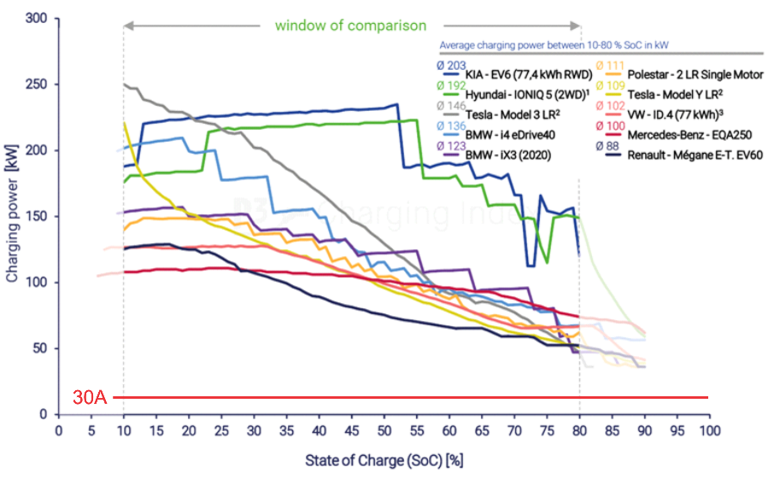Fig. 1 Charge Curve for High-Capacity Vehicles (400V and 800V)

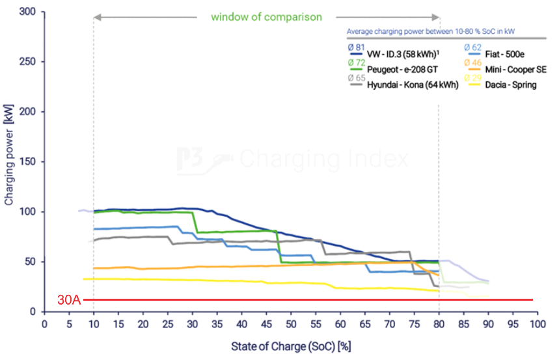Fig. 2 Charge Curve for Low-Capacity Vehicles (400V)

Figure 2 shows comparable data for a variety of EVS that have lower charging capacity. Even for these, the current draw in all cases is well above our 30A lower test point. Remember that the current drawn from an EVSE is controlled by the vehicle. It will draw from the EVSE as much current as it can up to the maximum value that the EVSE can supply.

Field Verification

Finally, there is the issue of field testing. In the field we do not generally have the facilities available that would be available in a type testing laboratory. For high power EVSE an inspector would need a 350kW test set to meet the 70% type evaluation requirement for a 500 kW EVSE. While possible to test at these levels in the field it is not practical or cost effective.

Chargers of this power level and greater will soon be in the marketplace. For field verification two approaches are provided. One uses a controllable load. Here we have the same low end test point as for type approval.

1. A point between 10% and 20% of the MDA, but not less than 30 A;

The two upper points are replaced by a single test point.

1. A point between 25 % and 100 % of the MDA, with the recommendation to test at the maximum power level within that range that is possible using the test equipment available.

Note: The test points (i) and (ii) above must not be at the same current level. It is recommended that the current levels should be separated to the extent that the test equipment will allow.

For practical reasons we have adopted a testing approach similar to what is used in electricity metering. In electricity metering, a meter with 200 A maximum current is tested over its full operating range 3 A to 200A during type testing. For verification, testing is done at only three points with the highest current being 30A. In testing a DC EVSE we have replaced the middle and upper end test points with a single test point at 25% to 100% of the MDA with **the recommendation that this test point be performed at the highest load available with the test equipment**. Referring to Fig. 1 and Fig.2, it can be seen that testing at a load of 150kW will cover most of the actual charging done in the US.

An option to perform the field test with an electric vehicle has also been provided. The test will be performed at whatever power level the EV being used requires based on its state of charge, battery temperature and charging capacity. This option exists already in section 3.40, but the existing section 3.40 provides no guidance as to acceptable test levels. When an EV is used the inspector has no control over the test parameters. Because there is no control, we propose to implement at least some limitation to ensure that the resulting test is appropriately meaningful about the transactional accuracy of the charger: The load presented by the vehicle must be greater than 40% of the MDA and greater than 30A. Absent these limitations, in theory a test operator could approach with a vehicle that was at 99% state of charge, and operate a test at, say, 5% of the charger’s MDA, a range at which the charger would not have been certified in the first place. Moreover, since with the EV as load there would be only one test point, it would be sensible to have that test point closer to the middle of the range. We propose a minimum current of 40% of the MDA, which we believe would enable lower-cost EVs to be used for tests at the charging stations widely in use today.

For DC systems it is anticipated that an electric vehicle may be used as the test load. Under that circumstance, testing at the load presented by the vehicle shall be sufficient for field verification provided that it is greater than 40 % of the MDA and no less than 30 A.

The original N.5 in HB44 2023 provided a statement on effectivity. That statement has remained unchanged.

New Definitions

In the 2022 version of the Handbook both the term “MDA” and maximum deliverable amperage” appeared in the code. In addition, the test section contained the following wording to refer to the test voltages:

not less than 85 % of the maximum deliverable amperes (expressed as MDA) as determined from the pilot signal

and

not less than 85 % of the maximum deliverable amperes current (expressed as MDA) as determined from the digital communication message from the DC EVSE

In the 2022 update cycle for the 2023 edition some but not all of the recommended changes were approved. As a result, the to be published 2024 edition how has inconsistent definitions and usage.

In HB44 there are two distinct meanings of maximum current. In sections S.5.2 and S.5.3 we are talking about the maximum current that the EVSE can deliver as installed under optimum conditions. This should be called maximum current deliverable. It is a fixed quantity known at installation and as such cal be indelibly marked on the EVSE. The second term is maximum deliverable amperes (MDA). The MDA is the maximum current available from the EVSE at the time of the test as determined by the Control Pilot PWM signal or via digital communication between the EVSE and EV or test equipment.

To clarify the usage and keep the historic meaning of MDA two definitions are proposed for addition to Appendix D:

Maximum current deliverable:  The maximum current that the EVSE can deliver as installed under optimum conditions. Abbreviated MCD.

Maximum deliverable amperage: The maximum current available from the EVSE at the time of the test as determined by the Control Pilot PWM signal or via digital communication between the EVSE and EV or test equipment. Abbreviated MDA.

There are at least three possible meanings for the concept of maximum current: the manufacturer’s design maximum for the charger; the maximum permissible in a given installation (limited by, say, the current capacity of the supply); or the maximum that is actually available at the time of a given charging session or accuracy test. For accuracy testing, the concept intended is the last of these three. For clarity and certainty, the proposal would add a definition identifying that meaning.

One objection to a prior version of EVF-23.7 was that it proposed to base maximum current on the fixed parameters of the charger and its installation, without taking account of temporary changes like power-sharing. The present proposal reverts to the concept that is in the existing code.

Another concern that has been raised is that it may be unusual to specify a test to be used in type evaluation that is different from the testing for field inspections. We have reviewed Handbook 44, and we found multiple precedents in which Handbook 44 has specified somewhat different or additional tests for the two different circumstances. As just one example, chapter 2.20, paragraph T.N.3.8 (for dynamic monorail scale systems) specifies an accuracy tolerance to be used in type evaluation that is different from the field inspection accuracy tolerance.

1. OIML G22 Electric Vehicle Supply Equipment (EVSE) - Metrological and technical requirements - Metrological controls and performance tests (2022) available on OIML.org